OpenSimQt Source Code & Compiling Help
Last updated Thursday April 7, 2011 by Paul Mitiguy

Windows specific information
Install a C++ compiler, preferably with Documentation such as Help files and Examples.
For example, I installed Microsoft Visual Studio 2008, version 9.0.2.

To install Qt binary libraries and include files for Windows.  - Visit Nokia’s download center at http://qt.nokia.com/downloads/  - Select LGPL license.  Licensing terms (http://qt.nokia.com/products/licensing) and summary from the “Qt legal gal” (http://blog.qt.nokia.com/2009/11/30/qt-making-the-right-licensing-decision/ ) are on Nokia website’s. A non-legal, non-binding, summary interpretation is that for practical purposes, LGPL Qt is free to use/deploy for commercial applications, without providing the commercial application’s source code, as long as there are no modifications to Qt source code and/or possibly no static linking to Qt .dlls. Provide the end-user the requisite Qt .dlls as well as the LGPL v. 2.1 licensing terms, e.g., the files LICENSE.LGPL and LGPL_EXCEPTION.txt. A summary of information is in the .zip file “QtNokiaLicensingLGPL.zip”.  Note: It seems unnecessary to download Qt source code from Nokia/Qt website. It seems that it is necessary to use Qt qmake (builds Microsoft Visual Studio .vcproj compiler file or makefile) and Qt moc (meta object compiler to convert Qt code to C++) as well as Qt’s .dlls.  - Click on Qt libraries 4.7.2 for Windows (VS 2008, 218 MB)  - This should link to: http://qt.nokia.com/downloads/windows-cpp-vs2008  - Click http://get.qt.nokia.com/qt/source/qt-win-opensource-4.7.2-vs2008.exe  - Download the installer to your computer and install Qt.  - Ensure the computer’s PATH environment variable has Qt’s bin on the path. For example, my computer’s PATH variable starts with C:\Qt\4.7.2\bin |   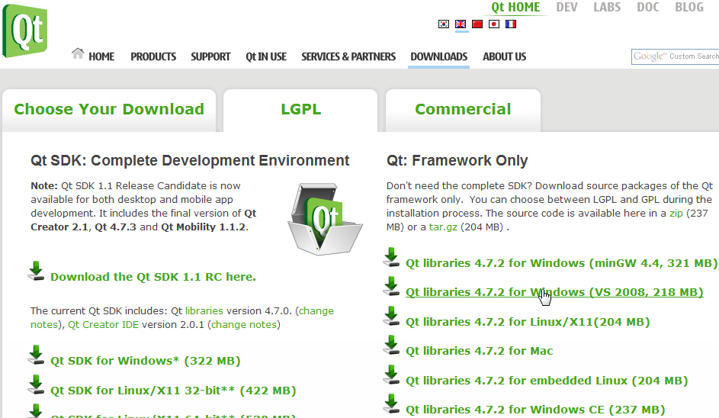  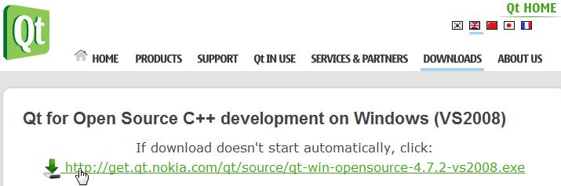

To download OpenSimQt source code to your computer.  - Visit www.simtk.org. If necessary, register and login with username/password.  In the Search SimTk.org box, type OpenSimQt and click  Click on the link OpenSimQt: C++ tool for easy-to-use biomechanics …  Shortcut: Go directly to https://simtk.org/home/opensimqt  - On left-hand panel, click on Advanced and then Source Code Repository.  - The instructions for using SVN (Subversion) to download the source code to your computer are provided on the html page that appears (summarized here).  - If necessary, install the SVN command line tool from …  - To download source, type: svn checkout https://simtk.org/svn/opensimqt  - …. |   

To use Qt’s qmake to create the OpenSimQt Microsoft Visual Studio .vcproj project or to have Qt’s qmake create a makefile for subsequent use by your compiler:  - Ensure qmake.exe is on a path specified in your computer’s PATH variable.  For example, ensure the computer’s PATH includes C:\Qt\4.7.2\bin  - Create a Microsoft Window’s shortcut to the cmd.exe command prompt.  Right-click on the shortcut to cmd.exe and change the “Start in” folder to the folder containing the file OpenSimQt.pro (e.g., C:\OpenSimQt\trunk).  - Double-click on the shortcut to cmd.exe to open the command prompt.  - To create a .vcproj in the directory ..\..\OpenSimQtBuilds, type  qmakeOpenSimQt.bat  - Alternately, to create a .vcproj in the current directory, type  qmake OpenSimQt.pro  - More info: The tutorial for how to use qmake to create your compiler’s Microsoft Visual Studio vcproj file or Macinstosh/Unix makefiles is at http://doc.trolltech.com/4.2/qmake-tutorial.html | 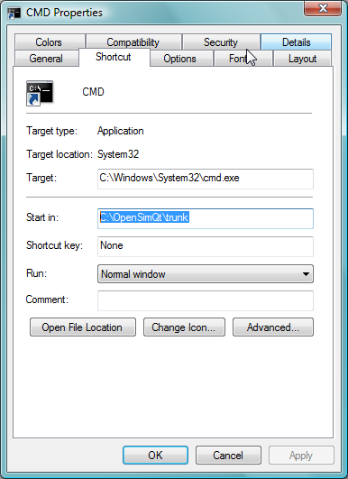  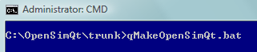

To install SimTK libraries and include files on Windows, Macintosh, or Linux Operating Systems
- Visit the SimTK Core Toolset project at http://www.simtk.org (https://simtk.org/home/simtkcore)
- Click the Downloads tab on the left-hand side of the page.
- Find your operating system (e.g., Windows) and click on the appropriate download link, e.g.,
SimTKcore_VC9.exe (72347 kB) |  |  |  |  | binary | Windows | Aug 16, 2010
Description: Installation package for SimTK Core 2.1 using Visual Studio 9 (2008).
- Install onto your computer, e.g., by double-clicking on SimTKcore_VC9.exe or unzipping to a folder of your choice, e.g., C:\SimTK
- Ensure you include the path to the SimTK header files, e.g., for Qt, add the following to the .pro file:
INCLUDEPATH += /SimTK/include/
- At the top of source code files that need to be aware of SimTK classes or methods, put the following:
#include <SimTKsimbody.h>

